Operating Instructions

MAIL-IN SERVICE
When shipping the unit carefully pack and send it prepaid, adequately insured and preferably in the original carton. Include a letter detailing the complaint and provide a day time phone and/or email address where you can be reached.

LIMITED WARRANTY LIMITS AND EXCLUSIONS
1) This Limited Warranty ONLY COVERS failures due to defects in materials or workmanship, and DOES NOT COVER normal wear and tear or cosmetic damage.
The Limited Warranty ALSO DOES NOT COVER damages which occurred in shipment, or failures which are caused by products not supplied by warrantor, or failures which result from accidents, misuse, abuse, neglect, mishandling, misapplication, alteration, faulty installation, set-up adjustments, misadjustment of consumer controls, improper maintenance, power line surge, lightning damage, modification, or service by anyone other than a Factory Service center or other Authorized Servicer, or damage that is attributable to acts of God.
2) THERE ARE NO EXPRESS WARRANTIES EXCEPT AS LISTED UNDER "LIMITED WARRANTY COVERAGE". THE WARRANTOR IS NOT LIABLE FOR INCIDENTAL OR CONSEQUENTIAL DAMAGES RESULTING FROM THE USE OF THIS PRODUCT, OR ARISING OUT OF ANY BREACH OF THIS WARRNTY. (As examples, this excludes damages for lost time, cost of having someone remove or re-install an installed unit if applicable, travel to and from the service, loss of or damage to media or images, data or other recorded content. The items listed are not exclusive, but are for illustration only.)
3) PARTS AND SERVICE, WHICH ARE NOT COVERED BY THIS LIMITED WARRANTY, ARE YOUR RESPONSIBILITY.

HDMI2.0 1x4 Splitter Extender
Support 60m(197ft) 4K@60HZ 4:4:4

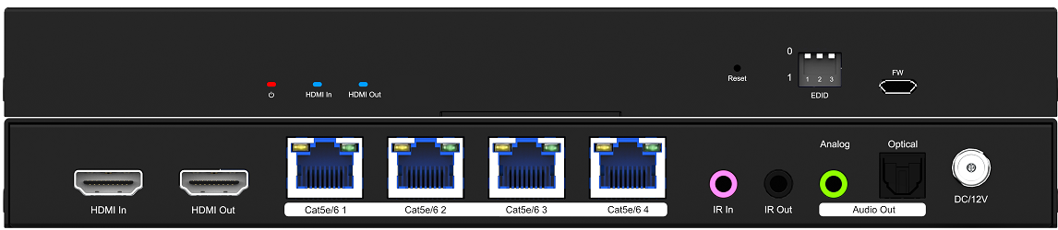

Operating Instructions

Notice
The information in this document is subject to change without notice. Every effort has been made in the preparation of this document to ensure accuracy of the contents, but all statements, information, and recommendations in this document do not constitute the warranty of any kind, express or implied.

Features
- HDMI2.0 splitter extender, bandwidth up to 18Gbps, deep color up to 4K@60Hz 8bit
- Distributes 1 HDMI source to 4 RJ45 output with 1 HDMI loop out
- Transmission distance up to 60m (197ft) at 4K@60Hz over Cat5e/6 cable
- HDCP2.2/1.4 Compliant
- Support analogue and Toslink SPDIF audio out on both TX and RX side
- Support HDR10, HLG
- Support LPCM2.0/5.1, Dolby Digital, DTS 5.1, Dolby Digital+, Dolby True HD
- Support Bi-Directional wide band IR
- Support auto downscale 4K@60hz to 1080P at RX end
- Support EDID management
- Support POC(RX powered by TX)
- Support firmware updating through Micro USB port
- With one built-in reset button for factory reset

Package Contents
- 1x Transmitter & 4x Receiver
- 1x 12V/2A DC Power Adapter
- 1 x User Manual
- 5x IR TX cables
- 5x IR RX cables
- 10x Mounting ears (2pcs for TX; 8pcs for RX)
- 1 x USB cable

2
Operating Instructions

MAINTENANCE
Clean this unit with a soft, dry cloth. Never use alcohol, paint thinner of benzine to clean this unit.

PRODUCT SERVICE
- Damage requiring service:
The unit should be serviced by qualified service personnel if:
- The DC power supply cord or AC adaptor has been damaged;
- Objects or liquids have gotten into the unit;
- The unit has been exposed to rain;
- The unit does not operate normally or exhibits a marked change in performance;
- The unit has been dropped or the cabinet damaged.
- Servicing Personnel: Do not attempt to service the unit beyond that described in
these operating instructions. Refer all other servicing to authorized servicing personnel.
- Replacement parts: When parts need replacing ensure the servicer uses parts
specified by the manufacturer or parts that have the same characteristics as the
original parts. Unauthorized substitutes may result in fire, electric shock, or other hazards.
4) Safety check: After repairs or service, ask the servicer to perform safety checks
to confirm that the unit is in proper working condition.

WARRANTY
If your product does not work properly because of a defect in materials or workmanship, our Company (referred to as "the warrantor" ) will, for the length of the period indicated as below, (Parts(2)Year, Labor(90) Days) which starts with the date of original purchase ("Limited Warranty period"), at its option either(a) repair your product with new or refurbished parts, or (b) replace it with a new of a refurbished product. The decision to repair or replace will be made by the warrantor.
During the "Labor" Limited Warranty period there will be no charge for labor.
During the "Parts" warranty period, there will be no charge for parts. You must mail-in your product during the warranty period. This Limited Warranty is extended only to the original purchaser and only covers product purchased as new. A purchase receipt or other proof of original purchase date is required for Limited Warranty service.

7
Operating Instructions

The Splitter has to work with Receivers

Connection Diagram

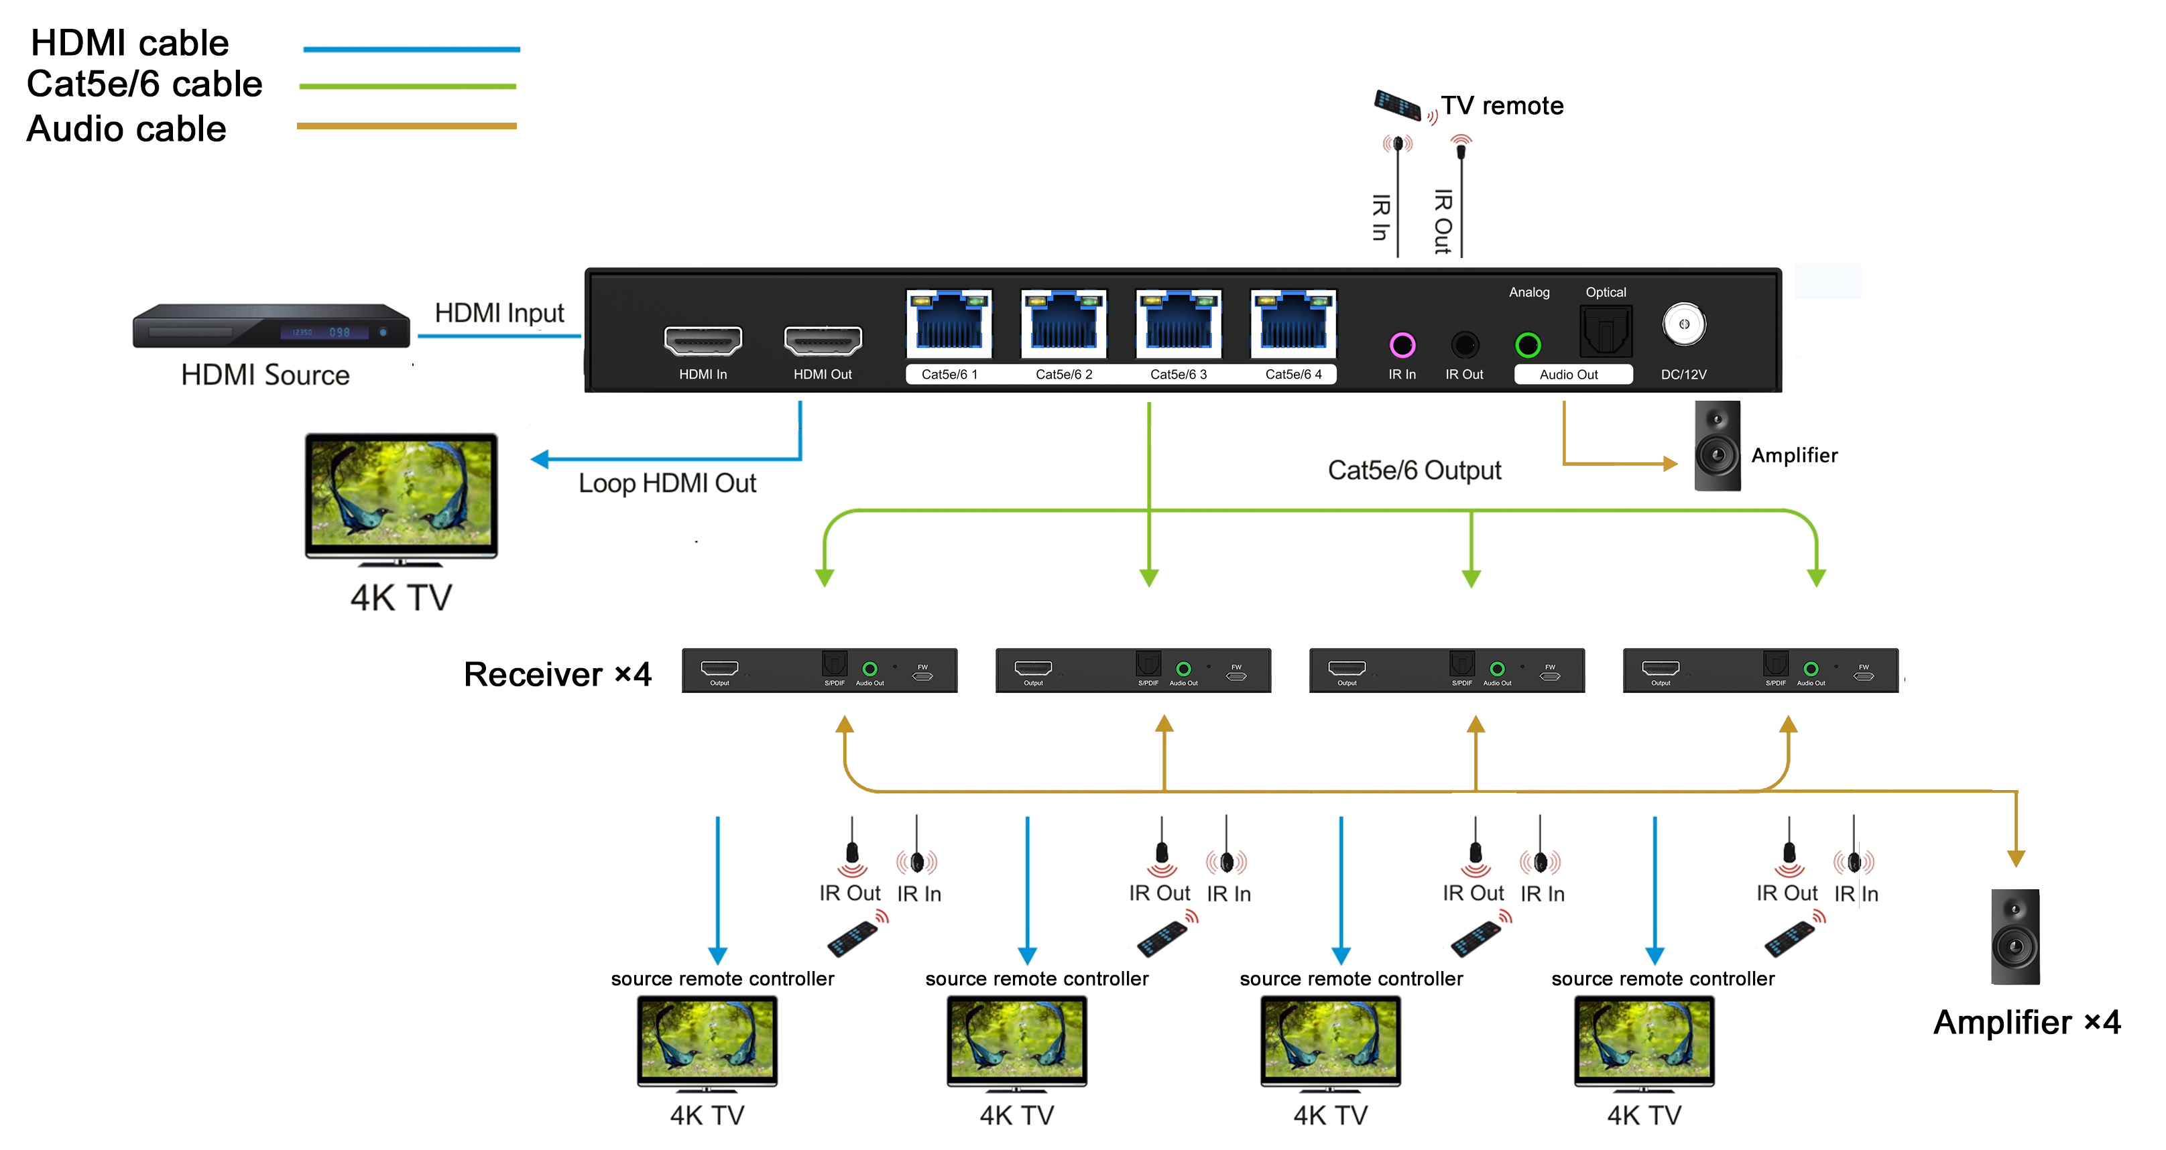

6
Operating Instructions

SPECIFICATIONS
Operating Temperature Range | -5 to +40℃(+23 to +104℉)
Operating Humidity Range | 5 to 90%RH (No Condensation)
Input Video format | 720P / 1080P / 4K@60hz
Data transfer speed rate | 18 Gbps(Maximum)
Input port | 1xHDMI
Output ports | 4xRJ45 output port, 1xHDMI loop out
Output Video Format Supported | DTV/HDTV: 480P/576P/720P/1080P, 4K  VESA resolution
Transmission Distance | 60m (197ft) at 4K@60Hz
Power consumption | 12.5W(Maximum)
Dimension (L×W×H) | TX: 229.5x113.4x24mm; RX:110.2x68.3x18mm
Net Weight | TX:1300g; RX:1600g(4pcs)

Connecting and operating
1) Connect the HDMI input sources to the HDMI Splitter.
2) Connect HDMI receiver over Cat5e/6 cables to the RJ45 port of both HDMI Splitter and Receiver, The RJ45 connections must follow EIA-TIA 568b standards.
3) Connect the HDMI output from the Receiver(RX) into the display HDMI input.
4) Plug the IR TX and IR RX cables into the matching IR ports of the splitter.
5) Plug the IR TX and IR RX cables into the matching IR ports of the receiver.
6) Power on the source and display.

3
Operating Instructions

Transmitter Panel Description
Front Panel
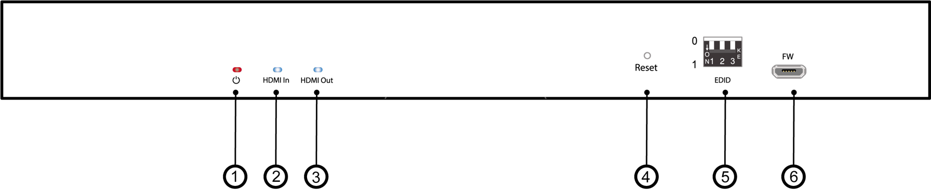

① Power indicator
② HDMI input indicator
③ HDMI loop out indicator
④ Reset button
⑤ EDID dip switch
⑥ Firmware update port

Rear Panel

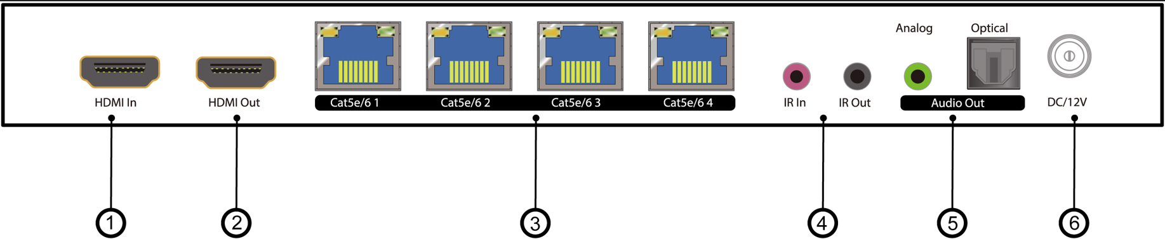

① HDMI input port
② HDMI loop out port
③ Cat5e/6 output 1~4 ports
④ IR in and out port
⑤ Audio output ports
⑥ DC 12V power input port

4
Operating Instructions

Receiver Panel Description

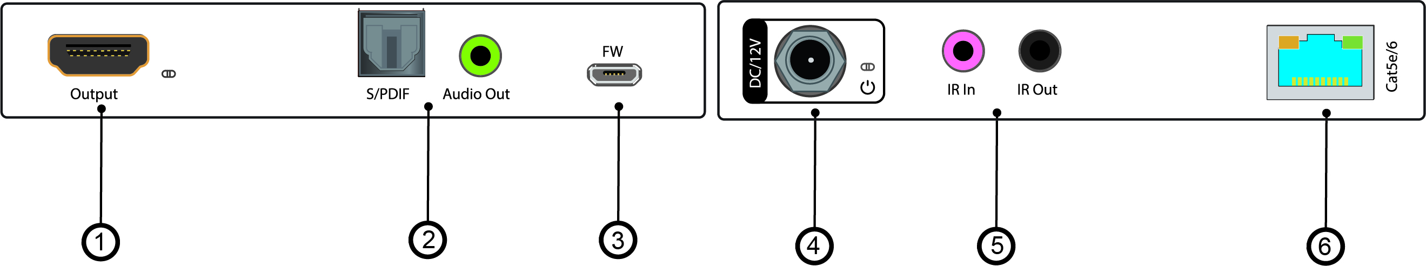

① HDMI output port ④ DC 12V power input port
② Audio output ports ⑤ IR in and out ports
③ Firmware update port ⑥ Cat5e/6 input port

EDID Switch Settings：
This splitter support EDID management through a 3 pin dip switch:
Up dial stands for 0; down dial stands for 1
Different digit combinations have different EDID effects according to the following table:
Switch Status | EDID Information
000 | Default-1 | 4K@60 4:2:0 2CH
010 | Default-2 | 4K@60 4:4:4 2CH
001 | Default-3 | 4K@60 4:4:4 5.1CH
100 | Default-4 | 4K@30 4:4:4 5.1CH
110 | Default-5 | 1080P60 2CH
111 | Copy loop | Copy EDID from loop out display

Note: all other digit combinations not listed above is for EDID 4K@60 4:2:0 2CH

Factory data reset：
Factory Settings can be restored through RESET button via long press 3 seconds

5

