**HDMI 2.1 1x2 HDMI Splitter, HDCP2.2**

**Supports 8K@60Hz(YUV 4:4:4), 48Gbps, HDR10, EDID Operating Instructions**

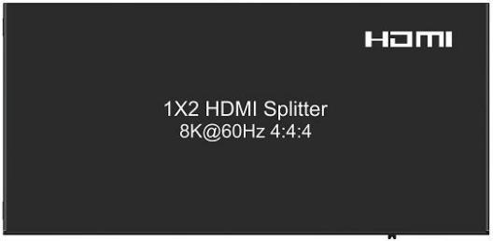

**Notice**

The information in this document is subject to change without notice. Every effort has been made in the preparation of this document to ensure accuracy of the contents, but all statements, information, and recommendations in this document do not constitute the warranty of any kind, express or implied.

**Features**

**l** Simultaneously displays an UItra Hi-Def source on up to two UItra HD displays.

**l** Support resolutions up to UItra HD 8K(7680x4320@60Hz YUV 4:4:4 ).

**l** Support three kinds of EDID handling abilities(Copy, Auto, Mixed EDID).

**l** Support HDCP2.2/ 1.4 Compliant.

**l** Support 10 bit Deep Color.

**l** Support LPCM 7.1/ 24-bit/ 96 kHz, Dolby Atmos and Dolby/ DTS-7.1.

**l** Support Dolby Vision, HDR10, HDR10+, HLG.

**l** Support Bandwidth 48Gbps.

**l** Support Downscaler function (HDMI output1).

**Package Contents**

**l** 1 x HDMI Splitter

**l** 1 x 5V/2A DC Adapter

**l** 2 x Mounting ears

**l** 1 x User Manual

**SPECIFICATIONS**

|  |  |
| --- | --- |
| Operating Temperature Range | -5 to +40℃(+23 to +104℉) |
| Operating Humidity Range | 5 to 90%RH (No Condensation) |
| Bandwidth frequency | 48Gbps |
| HDCP | HDCP2.2/ 1.4 |
| Input ports | 1xHDMI(female) |
| Output ports | 2xHDMI outputs(female) |
| Resolution outputs | up to 8K(7680x4320@60Hz YUV 4:4:4) |
| Dimensions(LxWxH) | 120.3x57.2x19mm |
| Power consumption | 5W(MAX) |
| Audio format | LPCM 7.1/ 24-bit/ 96 kHz, Dolby Atmos and Dolby/ DTS-7.1 |
| Net Weight | 191.7g |

**PANEL DESCRIPTIONS**

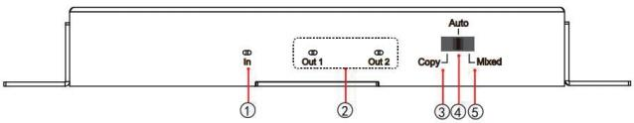

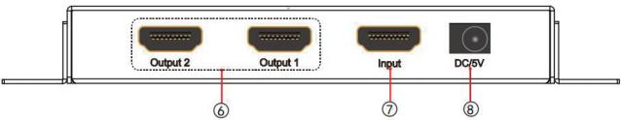

1 Indicator of HDMI input

2 Indicator of HDMI output

3 Switch to “Copy EDID” mode

4 Switch to “Auto EDID” mode

5 Switch to “ Mixed EDID” mode

6 HDMI output ports

7 HDMI input port

8 DC 5V Power supply

**EDID Introduction:**

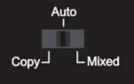

**Total 3 kinds of EDID mode:Copy, Auto, Mixed**

**Copy EDID:**

1). If both TVs connecting two HDMI out ports have same EDID:

No downscaler function, both HDMI out ports output the same resolution; EDID copy port fixed as HDMI out2;

**When TV connect to HDMI out2 only**, splitter copy EDID from output2, support input/ output upto 8k60hz YUV4:4:4, and Dolby vision;

**When TV connect to HDMI out1 only**, default fixed EDID 1080p60hz, support input/ output upto 1080p60hz only;

**When TVs connect to both HDMI out1 &out2**, splitter copy EDID from output2, support input & 2 outputs upto 8k60hz YUV4:4:4;

2). If both TVs connecting two HDMI out ports have different EDID:

With forced downscaler function;

Two HDMI out ports can output different resolution video;

Downscaler port fixed as HDMI out1; EDID copy port fixed as HDMI out2;

**When TV connect to HDMI out2 only**, splitter copy EDID from output2, support input/ output upto 8k60hz YUV4:4:4, and Dolby vision;

**When TV connect to HDMI out1 only**, default fixed EDID 1080p60hz, support input/ output upto 1080p60hz only;

**When TVs connect to both HDMI out1 &out2**, splitter copy EDID from output2, support input upto 8k60hz YUV4:2:0, output2 upto 8k60hz YUV4:2:0, output1 upto 4k60hz only(forced downscaler);

**Auto:**

No downscaler function, both HDMI out ports output the same resolution;

**When TV connect to HDMI out1 only**, splitter copy EDID from output1, support input/ output upto 8k60hz YUV4:4:4, and Dolby vision;

**When TV connect to HDMI out2 only**, splitter copy EDID from output2, support input/ output upto 8k60hz YUV4:4:4, and Dolby vision;

**When TVs connect to both HDMI out1 &out2**, mixed EDID(lowest resolution) generated from output1 &output2, support upto 8k60hz YUV4:4:4, output1 &output2 upto 8k60hz YUV4:4:4;

**Mixed EDID:**

With forced downscaler function;

Two HDMI out ports can output different resolution video;

Downscaler port fixed as HDMI out1;

**When TV connect to HDMI out2 only**, splitter copy EDID from output2, support input/ output upto 8k60hz YUV4:2:0, and Dolby vision;

**When TV connect to HDMI out1 only**, splitter copy EDID from output1, support input upto 8k60hz YUV4:2:0, output upto 4k60hz only(forced downscaler), and Dolby vision; **When TVs connect to both HDMI out1 &out2**, mixed EDID(highest resolution) generated from output1 &output2, support upto 8k60hz YUV4:2:0, output2 upto 8k60hz YUV4:2:0, output1 upto 4k60hz only(forced downscaler).

**Connecting and operating**

1) Connect the HDMI input source to input port of HDMI splitter.

2) Connect the HDMI splitter output ports to the displays.

3) Power up splitter, source and displays.

**Connection Diagram**

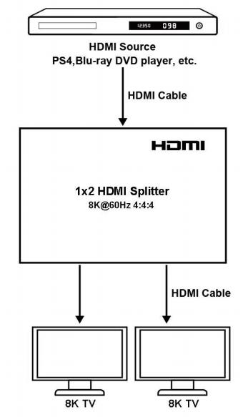

**Safety information**

**Safeguards**

**To reduce the risk of electric shock, do not expose this product to rain or moisture**

**PRODUCT SERVICE**

1) **Damage requiring service:** The unit should be serviced by qualified service

ae)Cl iower supply cord or AC adaptor has been damaged;

**()**jesit ralsiqei;the unit;

(d)The unit does not operate normally or exhibits a marked change in performance;

(e)The unit has been dropped or the cabinet damaged.

**Servicing Personnel:** Do not attempt to service the unit beyond that described in these operating instructions. Refer all other servicing to authorized servicing

personnel.

2) **Replacement parts:** When parts need replacing ensure the servicer uses parts specified by the manufacturer or parts that have the same characteristics as the

original parts. Unauthorized substitutes may result in fire, electric shock, or other hazards.

3) **Safety check:** After repairs or service, ask the servicer to perform safety checks to confirm that the unit is in proper working condition.

**WARRANTY**

workmanship, our Company (referred to as "the warrantor" ) will , for the length of the

If your product does not work properly because of a defect in materials or

period indicated as below, **(Parts(2)Years ,Labor(90) Days)** which starts with the date

of original purchase ("Limited Warranty period"), at its option either(a) repair your

product with new or refurbished parts, or (b) replace it with a new of a refurbished

product. The decision to repair or replace will be made by the warrantor.

During the "Labor" Limited Warranty period there will be no charge for labor.

During the "Parts" warranty period, there will be no charge for parts. You must mail-in your product during the warranty period. This Limited Warranty is extended only to the original purchaser and only covers product purchased as new. A purchase receipt or other proof of original purchase date is required for Limited Warranty service.

**Mail-In Service**

When shipping the unit carefully pack and send it prepaid, adequately insured and

preferably in the original carton. Include a letter detailing the complaint and provide a

day time phone and/or email address where you can be reached.

**LIMITED WARRANTY LIMITS AND EXCLUSIONS**

1) This Limited Warranty ONLY COVERS failures due to defects in materials or

workmanship, and DOES NOT COVER normal wear and tear or cosmetic damage. The Limited Warranty ALSO DOES NOT COVER damages which occurred in

shipment, or failures which are caused by products not supplied by warrantor,or failures which result from accidents,misuse,abuse,neglect, mishandling,

misapplication, alteration, faulty installation, set-up adjustments, misadjustment of consumer controls, improper maintenance, power line surge, lightning damage,

modification, or service by anyone other than a Factory Service center or other Authorized Servicer, or damage that is attributable to acts of God.

I HIT"WIESIS LNIR

INCIDENTAL OR CONSEQUENTIAL DAMAGES RESULTING FROM THE USE OF

THIS PRODUCT, OR ARISING OUT OF ANY BREACH OF THIS WARRNTY. (As

examples, this excludes damages for lost time, cost of having someone remove or

re-install an installed unit if applicable, travel to and from the service, loss of or

damage to media or images, data or other recorded content. The items listed are not

3) PARTS AND SERVICE, WHICH ARE NOT COVERED BY THIS LIMITED WARRANTY, ARE YOUR RESPONSIBILITY.

exclusive, but are for illustration only.